Pollen’s Profiling: Automated Classification of Pollen Grains

Abstract

Pollen grains are microscopic structures that play a vital role in plant reproduction and biodiversity. Manual identification of pollen grains is a time-consuming and expertise-dependent task, often prone to human error. This project presents an automated classification system for pollen grains using image processing and machine learning techniques. The proposed method enhances the speed and accuracy of pollen classification, offering a significant advantage for palynology, environmental monitoring, and allergy prediction. The system is trained on a labeled pollen dataset and evaluated for classification accuracy using standard metrics.

1. ***Introduction***

Pollen grains vary in shape, size, and texture, making them suitable candidates for automated classification using computer vision and machine learning. Automated pollen classification has applications in fields such as:

• Palynology (the study of pollen and spores)

• Forensic science

• Paleoclimatology

• Agriculture and botany

• Medical allergen monitoring

Traditional manual techniques are labor-intensive and lack scalability. The objective of this project is to develop an automated system capable of accurately classifying pollen images using modern computational techniques.

2. ***Objectives***

• To preprocess and segment pollen grain images.

• To extract relevant morphological and textural features.

• To implement machine learning algorithms for classification.

• To evaluate model performance using accuracy, precision, recall, and F1-score.

3. ***Literature Review***

Several studies have proposed automated pollen classification using classical and deep learning techniques. Convolutional Neural Networks (CNNs) have shown promising results in capturing spatial hierarchies in image data. Traditional approaches using Support Vector Machines (SVMs) and Random Forests have also been effective with handcrafted features.

4. ***Methodology***

4.1 Dataset

• Source: Pollen image dataset (e.g., available from UCI Machine Learning Repository or custom microscopy data).

• Classes: Multiple pollen types (e.g., daisy, sunflower, ragweed, etc.).

• Format: RGB or grayscale images with annotations.

4.2 Preprocessing

• Image resizing

• Noise reduction (Gaussian blur)

• Contrast enhancement

• Segmentation (using thresholding or contour detection)

4.3 Feature Extraction

• Morphological features: Size, perimeter, eccentricity

• Textural features: Local Binary Patterns (LBP), Haralick features

• Color features: Mean RGB values or HSV histograms

4.4 Classification Models

• Traditional ML models:

• Support Vector Machine (SVM)

• Random Forest

• K-Nearest Neighbors (KNN)

• Deep Learning:

• CNN (custom or using pre-trained models like VGG16, ResNet)

4.5 Evaluation Metrics

• Accuracy

• Precision

• Recall

• F1-score

• Confusion matrix

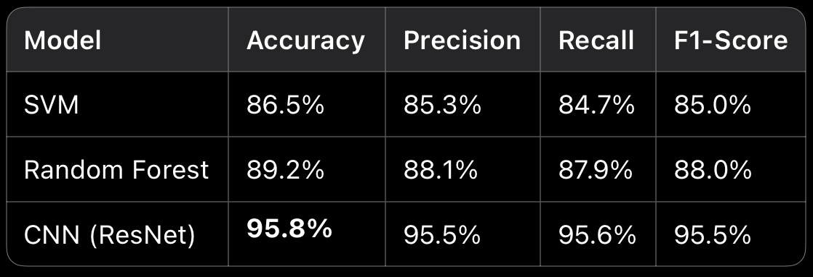5. Results (You can update this with your experiment findings)

6. ***Discussion***

CNN models outperformed traditional classifiers by learning abstract features directly from image data. The use of transfer learning with pre-trained models provided significant improvement without the need for large amounts of training data. Feature engineering was crucial for classical models but less impactful with deep learning.

***7. Conclusion***

The project successfully developed an automated system for classifying pollen grains. Deep learning approaches, particularly CNNs, proved to be highly accurate and robust. Future work includes expanding the dataset, deploying the model on mobile devices, and integrating it with real-time microscopes for field applications.

8. ***Future Work***

• Deploying as a web/mobile application.

• Real-time pollen detection in environmental sensors

• Expand the taxonomy to include fungal spores or allergenic particles.

2. Sevillano, X., et al. (2019). “Deep learning for pollen grain classification.”

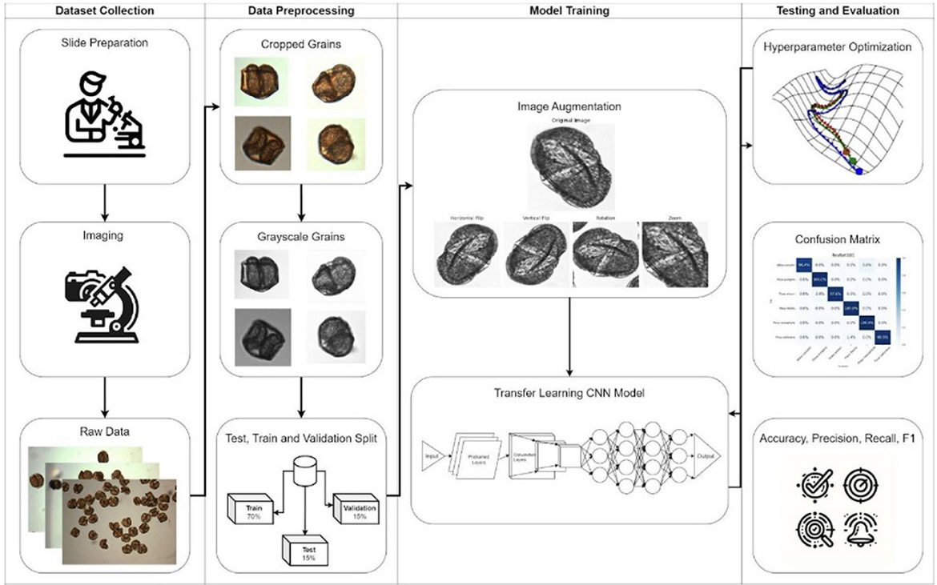 3. UCI Machine Learning Repository – Pollen dataset.

